Practice your times tables up through 12’s.

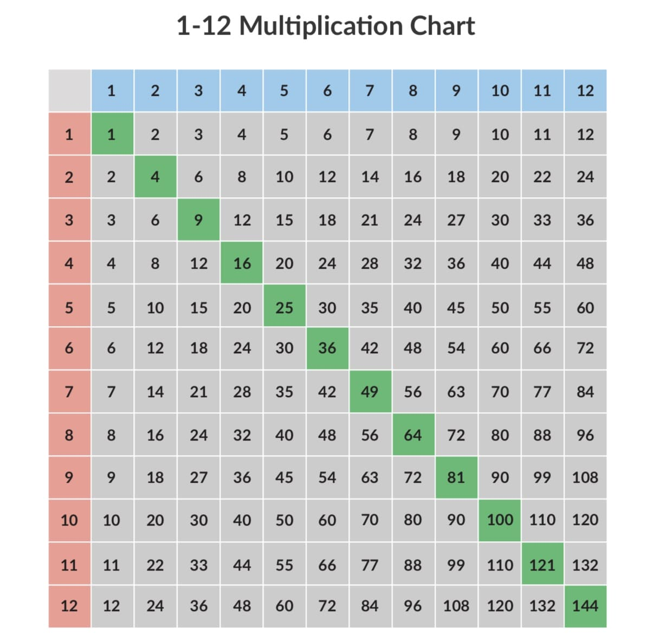

Tips for the 1 times table

Anything multiplied by one stays that number. These equations always mean there’s only one group of numbers.

Tips for the 2 times table

Anything multiplied by two is being **doubled**. Students can also think of this as adding two of the same number together.

**6 × 2 is the same as 6 + 6.**

**Learn TO COUNT by twos: 2, 4, 6, 8, 10, 12, 14, 16, 18, 20, 22, 24, etc. there is a pattern that repeats 2, 4, 6, 8,0 at the end of all the twos.**

Tips for the 3 times table

Three doesn’t have any rules that make its multiplication table easy to memorize, but there is a pattern for every ten multiples of three:

**3, 6, 9, 12, 15, 18, 21, 24, 27, 30**

The last digit of these multiples always repeat, which means that students can remember these digits to help them with the three multiplication tables.

Take a look at the next ten multiples of three:

**33, 36, 39, 42, 45, 48, 51, 54, 57, 60**

The last digits in both groups are the same: **3, 6, 9, 2, 5, 8, 1, 4, 7, 0**.

If students can remember this order they will at least know what the last digit of any multiplication of three is. For example, numbers that end with a **nine** that are then multiplied by **three** are going to then become a number that ends with a **seven**.

**9 × 3 = 27 19 × 3 = 57 159 × 3 = 477 1,428,659 × 3 = 4,285,977**

Teach your students the pattern of the three multiplication table as if it were a phone number, **(369) 258-1470**.

### Tips for the 4 times table

When a number is multiplied by four, double it and then double it again. It’s not the most clever trick, but it works!

**8 × 4 becomes 8 + 8 = 16 → 16 +16 = 32.**

### Tips for the 5 times table

Five is one of the easiest multiplication tables to master. Teach students that the five times table always follows the pattern of ending with:

**5, 0, 5, 0, 5, 0...**

Odd numbers multiplied by five are going to end with a five, while even numbers multiplied by five will end with a zero.

### Tips for the 6 times table

When multiplying an even number by six, the solution always ends with the last digit of the number that’s being multiplied.

**2 × 6 = 12        74 × 6 = 444        216 × 6 = 1,296        1,238 × 6 = 7,428**

Unfortunately, this trick only works for even numbers, and **not** for odd numbers.

### Tips for the 7 times table

We can use our previous tips to figure out the first few multiples of seven:

* Multiplying seven by two is the same as doubling seven — 14
* Three times seven results in a number that ends in a one — 21
* Multiplying seven by four is like doubling it twice — 28
* Multiplying an odd number by five will give a solution that ends in five — 35

But what about remembering later multiples of seven?

Here is a handy trick for seven times eight. The solution for seven times eight is like counting upwards:

**5-6-7-8**

**7 × 8 = 56**

Now your students have another memory trick to help them through their seven times tables.

### Tips for the 8 times table

Double, double, and then double again!

**8 × 8 = 64**

**8 + 8 = 16 → 16 + 16 = 32 → 32 + 32 = 64**

### Tips for the 9 times table

The nine multiplication table seems hard to learn, but there are two tips that can make them simple.

Multiplying by nine is the same as multiplying by ten and then subtracting the other number:

**9 × 5 = 45**

**Or**

**(10 × 5) - 5 = 50 - 5 = 45**

The second tip works for the first ten multiples of nine. Every time students increase what nine is multiplied with, the tens column of the solution increases by one, while the ones column decreases by one.

[**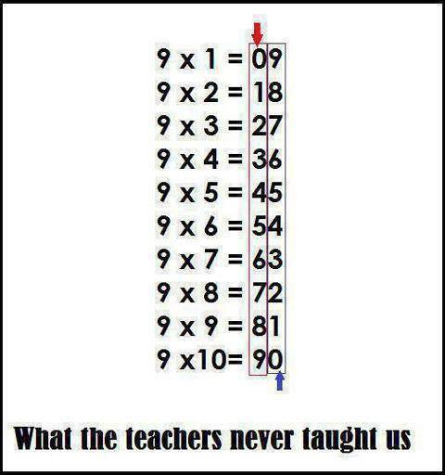Credit: VIRALNOVA**](https://images.prismic.io/prodigy-website/13501a32-c297-46d1-b756-444c2139f7e7_multiplication-chart-pdf.jpg?auto=compress,format)

### ****Tips for the 10 times table****

Ten has the easiest multiplication table to remember. Tell students to add a zero to the end of whichever number they’re multiplying by ten.

**10 × 4 = 40**

**10 × 7 = 70**

**10 × 11 = 110**

**10 × 123 = 1,230**

### Tips for the 11 times table

Up to eleven times nine, tell students they can repeat the digit they’re multiplying by eleven.

[**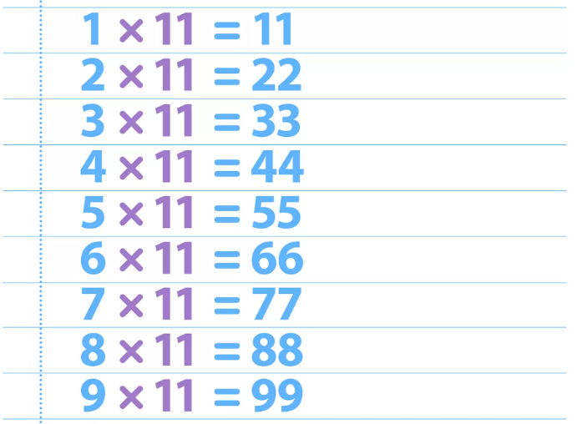Credit: DKfindout!**](https://images.prismic.io/prodigy-website/ebb7b615-94e1-42ee-b10a-6878bdc07602_multiplication-chart-printable.png?auto=compress,format)

### ****Tips for the 12 times table****

To make the twelve multiplication table easier, split it into two parts, ten and two. Then add them together!

**12 × 6 = ?**

**(10 × 6) + (2 × 6) = ?**

**60 + 12 = 72**

Long division is the opposite math operation of multiplication. If you know your times tables, you can get your division!

# Step by Step Guide for Long Division

## Long division

## What is long division?

Long division is a way to solve division problems with large numbers. Basically, these are division problems you cannot do in your head.

## Getting started

One of the problems students have with long division problems is remembering all the steps. Here’s a trick to mastering long division. Use the acronym **DMSB**, which stands for:

**D = Divide**  
**M = Multiply**  
**S = Subtract**  
**B = Bring down**

This sequence of letters can be hard to remember, so think of the acronym in the context of a family: 

**Dad, Mother, Sister, Brother**.

Write D M S B in the corner of your worksheet to remember the sequence you’re about to use.

## How to write it down

First, you have to write down the problem in long division format. A typical division problem looks like this:

**Dividend ÷ Divisor = Quotient**

To write this down in long division format it looks like this:



Let’s try a fairly simple example:

**65 ÷ 5 = ?**

Now, let’s write that problem down in the long division format:

Long division

 We’re ready to start using the acronym: **D M S B**

## Step 1: D for Divide

How many times will 5 go into 65? That’s too hard to work out in your head, so let’s break it down into smaller steps.

The first problem you’ll work out in this equation is how many times can you divide 5 into 6. The answer is 1. So you put 1 on the quotient line.

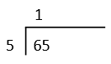

Step 2: M for Multiply

You multiply your answer from step 1 and your divisor: 1 x 5 = 5. You write 5 under the 6.

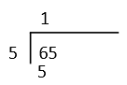

Step 3: S for Subtract

Next you subtract. In this case it will be 6 – 5 = 1.

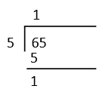

 Step 4: B for Bring down

The last step in the sequence is to bring down the next number from the dividend, which in this case is 5. You write the 5 next to the 1, making the number 15.

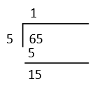

Now you start all over again:

## Step 1: D for Divide

How many times can you divide 5 into 15. The answer is 3. So you put 3 on the quotient line.

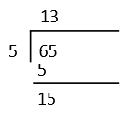

Step 2: M for Multiply

You multiply your answer from step 1 and your divisor: 3 x 5 = 15. Write this underneath the 15.

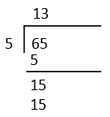

 Step 3: S for Subtract

Now we subtract 15 from 15. 15 – 15 = 0.

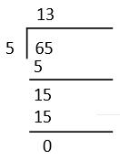

 There is no need for step 4. We have finished the problem.

Here is a decimal deivison….it is mostly the same as the whole number division.